**Дата**: 28.11.2024

**Клас**: 9-Б

**Предмет**: англійська мова

**Тема:** Незвичні професії.

**Мета:** : формувати навички вживання лексичних одиниць по темі; удосконалювати навички читання, аудіювання й усного монологічного мовлення; розвивати пізнавальні інтереси учнів; виховувати інтерес до самостійного пошуку потрібної інформації, а також загальну культуру учнів.

**Вчитель**: Руда Д.В.

Хід уроку

1.Greeting

Good afternoon, guys! I’m glad to see you. Are you ready to start our

lesson? All set?

2. Wаrm up / Listening

Уважно слухати аудіо трек і дати відповідь на питання вчителя усно <https://www.youtube.com/watch?v=AUNmsf25-W4> . The 10 Weirdest Jobs in the World and What They Pay.

3. Speaking

What job would you most like to do?

What are the names of some of the people with that job?

Do you personally know any one with that job?

How long do you plan to keep it for?

When do plan to retire?

What other fields or work will that job make you qualified for?

What are the work details of that job; what will be your duties at that job?

What steps are required from you to become a/an...?

So, how long before fore you become a/an...; at what ages will you both start and finish this/each job/career?

What do you hope to spiritually gain from that job?

What do you wish to physically gain; what kind of things would you like to buy with your money?

How much money do you need to make to fulfill you dreams and desires?

If money weren't a problem for you, which job would you prefer to have?

How does money affect your decisions?

How do your wants and desires affect your career options and goals?

How many years of schooling would you prefer to have?

Can you improve on the way things are now being done in the field you choose?

4. Повторення

Повторення **past perfect**.

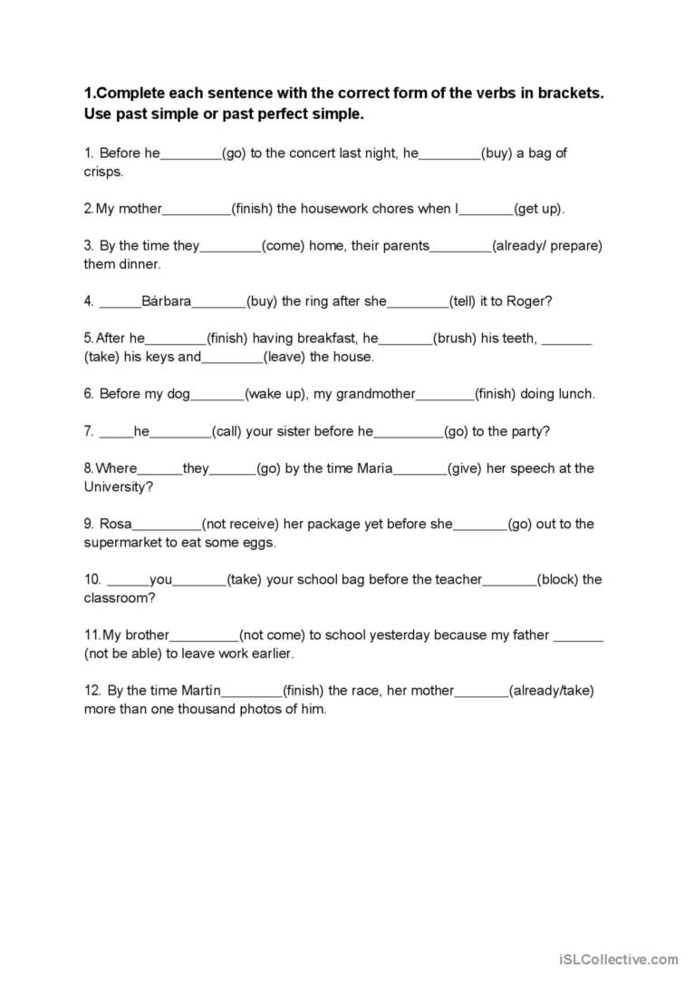

Повторити **Defining and non-defining relative clauses**

<https://wordwall.net/ru/resource/1258784/non-defining-relative-clauses>

<https://wordwall.net/ru/resource/26656731/defining-and-non-defining-relative-clauses>

5. Writing

Виконати вправу подану нижче на закріплення словника , пов’язаного з професіями. <https://www.liveworksheets.com/w/en/english-second-language-esl/845476>

6. Homework

1. Виконати письмово вправу 5 стр 95.

2. Вивчити слова по темі професії на стр 93,94, 95.